 | American International University-Bangladesh (AIUB)  Department of Computer Science
 | Course Name: COMPUTER GRAPHICS |  | Course Code: CSE 4118
 | Faculty Name: DIPTA JUSTIN GOMES |  | Semester: FALL 2025-2026
 | Section: J  Student Name: NILOY PAUL |  | MID Term LAB Task-4  Student ID: 23-51773-2

Object & Midpoint Circle

- Using opengl Implement the Midpoint Circle Algorithm where the center is (-2, -2) and the radius is 50. The range of X-Axis is -200 to 200 and Y-Axis is -200 and 200.

- Draw the following:

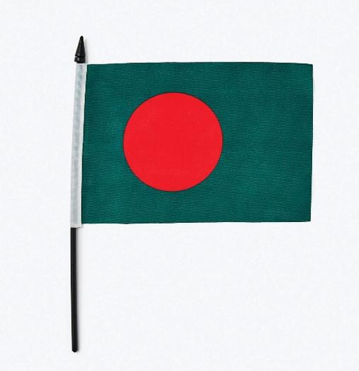

OpenGL Code
Question - 1
Midpoint Circle
#include<windows.h>
#include<iostream>
#include<math.h>
#include <stdio.h>
#include<GL/gl.h>
#include <GL/glut.h>

using namespace std;

int xc = -2; // center x
int yc = -2; // center y
int r = 50; // radius

// Function to draw 8 symmetric points
void draw8Points(int xc, int yc, int x, int y)
{
glBegin(GL_POINTS);
glVertex2i(xc + x, yc + y);
glVertex2i(xc - x, yc + y);
glVertex2i(xc + x, yc - y);
glVertex2i(xc - x, yc - y);

glVertex2i(xc + y, yc + x);
glVertex2i(xc - y, yc + x);
glVertex2i(xc + y, yc - x);
glVertex2i(xc - y, yc - x);
glEnd();
}

// Midpoint Circle Algorithm
void midpointCircle()
{
int x = 0;
int y = r;
int d = 1 - r; // initial decision parameter

draw8Points(xc, yc, x, y);

while (x < y)
{
if (d < 0)
{
d += 2 * x + 3;
}
else
{
d += 2 * (x - y) + 5;
y--;
}
x++;

draw8Points(xc, yc, x, y);
}
}
void display(void)
{
glClear(GL_COLOR_BUFFER_BIT);
midpointCircle();
glFlush();
}

void myInit(void)
{
glClearColor(1, 1, 1, 0);
glColor3f(1, 0, 0);
glPointSize(3.0);

glMatrixMode(GL_PROJECTION);
glLoadIdentity();
// Required coordinate system
gluOrtho2D(-200, 200, -200, 200);
}
int main(int argc, char** argv)
{
glutInit(&argc, argv);
glutInitDisplayMode(GLUT_SINGLE | GLUT_RGB);
glutInitWindowSize(640, 480);
glutInitWindowPosition(100, 150);
glutCreateWindow("Midpoint Circle Algorithm");

glutDisplayFunc(display);
myInit();
glutMainLoop();

return 0;
}
Output
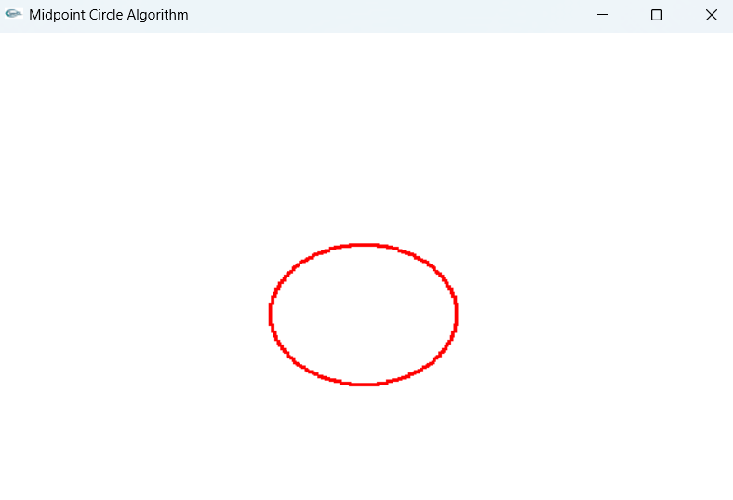
Question - 2
Object: Bangladesh Flag
#include<windows.h>
#include<iostream>
#include<math.h>
#include <stdio.h>
#include<GL/gl.h>
#include <GL/glut.h>

using namespace std;

float PI = 3.1416;

// Draw a Filled Circle using Triangle Fan
void drawFilledCircle(GLfloat x, GLfloat y, GLfloat radius)
{
int triangleAmount = 100;
float twicePi = 2 * PI;

glBegin(GL_TRIANGLE_FAN);
glVertex2f(x, y); // circle center
for(int i = 0; i <= triangleAmount; i++)
{
glVertex2f
(
x + (radius * cos(i * twicePi / triangleAmount)),
y + (radius * sin(i * twicePi / triangleAmount))
);
}
glEnd();
}

void display(void)
{
glClear(GL_COLOR_BUFFER_BIT);
// Center offset
int cx = 50;
int cy = 20;

// FLAG POLE - BLACK
glColor3ub(0,0,0);
glLineWidth(6.0);
glBegin(GL_LINES);
glVertex2i(-150 + cx, -150 + cy);
glVertex2i(-150 + cx, 70 + cy);
glEnd();

// Pole tip triangle - BLACK
glBegin(GL_TRIANGLES);
glColor3ub(0,0,0);
glVertex2i(-150 + cx, 75 + cy);
glVertex2i(-155 + cx, 62 + cy);
glVertex2i(-145 + cx, 62 + cy);
glEnd();

// GREEN RECTANGULAR
glColor3ub(0, 106, 78);
glBegin(GL_QUADS);
glVertex2i(-150 + cx, 60 + cy);
glVertex2i( 50 + cx, 60 + cy);
glVertex2i( 50 + cx, -60 + cy);
glVertex2i(-150 + cx, -60 + cy);
glEnd();

// RED CIRCLE
glColor3ub(244, 42, 65);
drawFilledCircle(-50 + cx, 0 + cy, 35);

// WHITE STRIP ON POLE
glColor3ub(255, 255, 255);
glLineWidth(7.0);
glBegin(GL_LINES);
glVertex2i(-150 + cx, -60 + cy);
glVertex2i(-150 + cx, 60 + cy);
glEnd();
glFlush();
}

// INITIALIZATION FUNCTION
void myInit(void)
{
glClearColor(0.90, 0.90, 0.90, 0.0); // Light gray background
glColor3f(0,0,0);
glPointSize(3.0);
glMatrixMode(GL_PROJECTION);
glLoadIdentity();
gluOrtho2D(-200, 200, -200, 200);
}

int main(int argc, char** argv)
{
glutInit(&argc, argv);
glutInitDisplayMode(GLUT_SINGLE | GLUT_RGB);
glutInitWindowSize(640, 480);
glutInitWindowPosition(100, 150);
glutCreateWindow("Bangladesh Flag - OpenGL");
glutDisplayFunc(display);
myInit();
glutMainLoop();

return 0;
}
Output
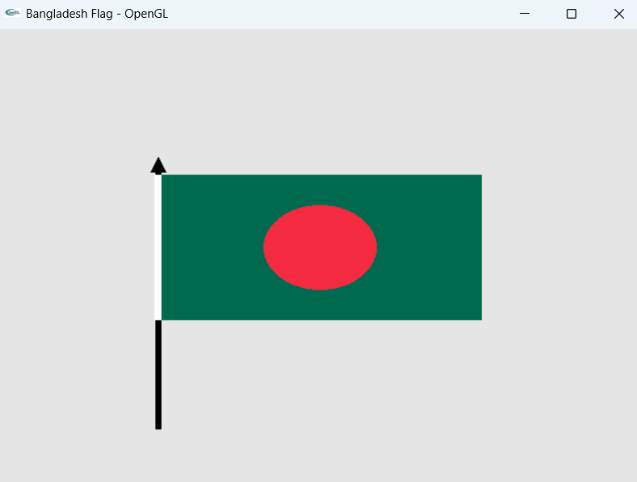

THE END

